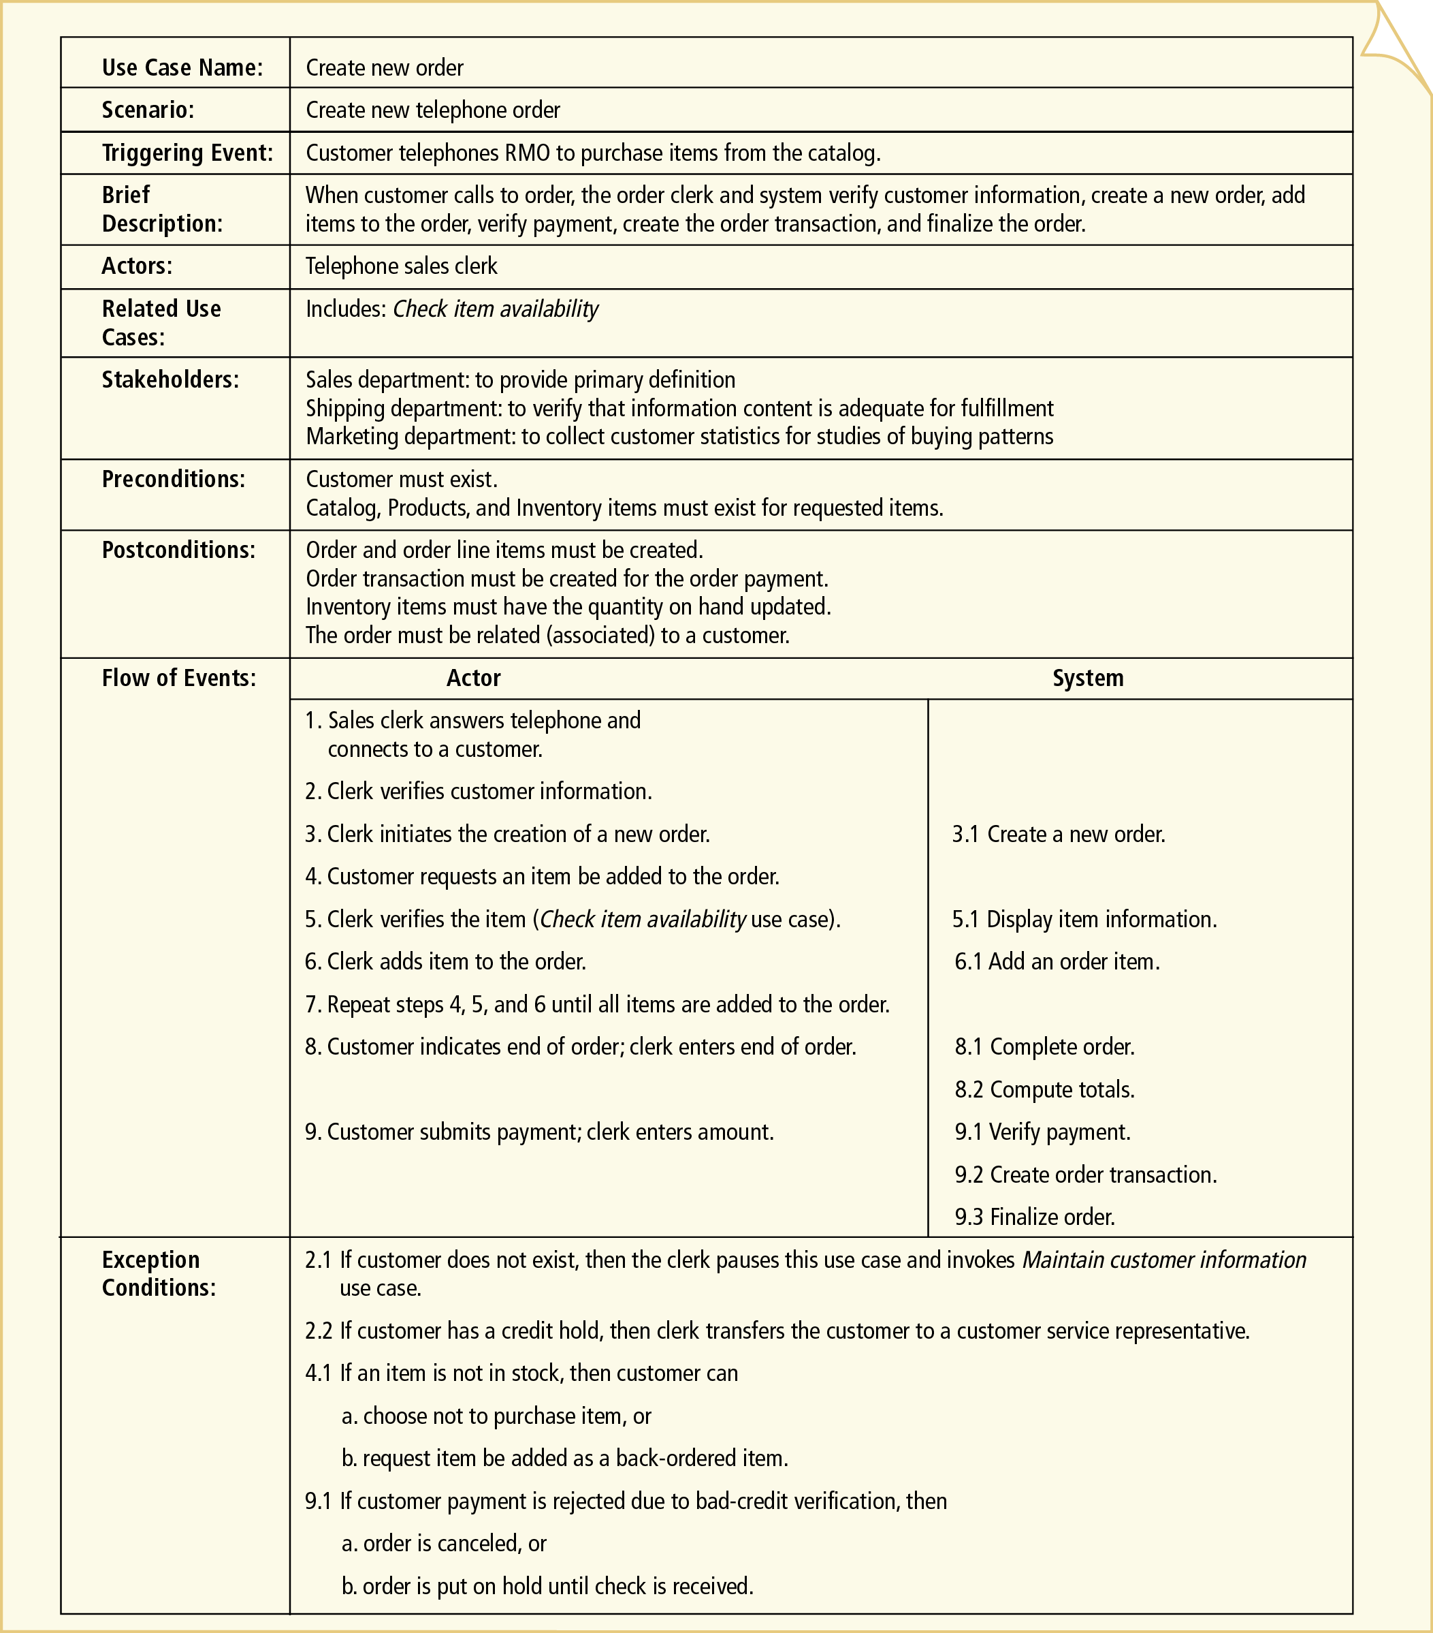
It is my opinion that is not necessary. –ff-

